**DAV College Amritsar**

Synopsis on

E-Auction



**Submitted To :- Submitted by:-10722123523, Prof. Harsimran Singh Anand 10722123551 Department of Computer App.**

**ACKNOWLEDGEMENT**

We would like to pay special thanks to **Dr. Amardeep Gupta**, Principal DAV College, Amritsar, for his valuable guidance. We take this golden opportunity to express our sincere thanks to the Project Guide **Prof. Harsimran Singh** **Anand** for their time, help and cooperation. Their way of motivating modems working and handling problems without losing patience inspired us a lot.

We are also thankful to **Prof. Vikram Sharma**, Head of Department for the support and encouragement given. We are thankful to all above mentioned persons who provided us all the information required for this project. We both are extremely thankful to all of them for their valuable guidance and knowledge. With their able guidance, the completion of this project becomes smooth and easy.

At the last but not the least, we are thankful to our parents for helping us around the clock. They have encouraged us for whatever we have done. It is all about their blessings and good wishes for which we owe a debt of gratitude to them.

**Thank you All**

**Name:- Vivek Pathak** **Name:- Nitish Saini**

**Roll No. :-107221323523** **RollNo. :-10722123551**

**DECLARATION**

We, the undersigned, hereby declare that the Project work entitled "Bid Zone (E-Auction Website)" submitted to the Guru Nanak Dev University, Amritsar in partial fulfilment of the requirement of the Degree of Bachelor of Computer Applications (BCA) is an authentic record of our own work carried out by VIVEK PATHAK and NITISH SAINI under the supervision of PROF. HARSIMRAN SINGH ANAND Department of Computer Science and IT DAV College, Amritsar.

The matter embodied in this Project Report has not been submitted by us or anybody else for the award of any other degree or any diploma.

We understand the significance of academic integrity and ethical conduct, and we attest that no part of this project has been plagiarized or misrepresented. We take full responsibility for the authenticity and accuracy of the content presented herein.

**SIGNATURES :-**

**Vivek Pathak Nitish Saini**

**BCA(6th Sem) BCA(6th Sem)**

**Roll No:- 10722123523 Roll No:- 10722123551**

**CERTIFICATE**

This is to certify that the PROJECT work of an ***E-Auction Website*** entitled “Bid Zone” in the partial fulfilment of the of Degree of Bachelor of Computer Applications (BCA) was carried out by VIVEK PATHAK and NITISH SAINI at the Department of Computer Science & IT DAV College, Amritsar.

This is a bonafide piece of work and has not been submitted in part or fall for any other degree/diploma at this or any other university/institute.

**Place: Amritsar**

**Date:**

**PROF. VIKRAM SHARMA**

Department of Comp. Science & IT

DAV College, Asr

**PROF. HARSIMRAN SINGH ANAND**

Department of Comp. Science & IT

DAV College, Asr

**INDEX**

| **S.No.** | **Topic Name** | **Page No.** |
| --- | --- | --- |
| 1. | Introduction To The Project | 1 |
| 2. | Existing System | 2 |
| 3. | DrawBacks Of Existing System | 2 |
| 4. | Problem Definition | 3 |
| 5. | Proposed System | 3 |
| 6. | FrontEnd & BackEnd Tools | 4 |
| 7. | FrontEnd | 4 |
| 8. | BackEnd | 6 |
| 9. | System Design | 12 |
| 10. | Database Design | 15 |
| 11. | Process Design | 16 |
| 12. | Coding | 20 |
| 13. |  |  |
|  |  |  |

***Introduction to the Project***

**Meaning**

E-Auction stands for Electronic Auction. It is a kind of Auction in which auction is performed in online mode and all the goods and services are bought and sold through a competitive bidding process.

**Objective**

The main objective of the project is to develop an online auction platform that facilitates the buying and selling of various products through a transparent and efficient bidding process. The platform aims to provide a user-friendly interface for both sellers and buyers, ensuring a secure and fair environment for conducting electronic auctions.

**Aim**

The system aims to streamline the traditional auction process, making it more accessible and efficient for participants.

***Existing System***

The existing system for traditional auctions relies on physical events where buyers and sellers gather at a specific location to participate in the bidding process. Auctioneers conduct the event manually, present items and also manage the bids personally. Participants may submit bids through gestures or verbal communication.

**DrawBacks of Existing System**

* **Geographical Limitations :-** Traditional auctions are constrained by location, limiting the participation of individuals who cannot physically attend the event. This results in a restricted pool of potential buyers and sellers.
* **Manual Process :-** The manual nature of traditional auctions introduces inefficiencies, including paperwork, bid recording, and time-consuming administrative tasks. This can lead to errors, delays and increased operational costs.
* **Time Constraints :-**  Traditional auctions may lack a sense of urgency, potentially leading to prolonged processes and delays. This can be inconvenient for participants who prefer a more efficient and time-sensitive experience.
* **Limited Record-Keeping :-** Manual record-keeping may be prone to errors, and tracking bid history or maintaining comprehensive records for audit purposes can be challenging. This lack of robust record-keeping can affect accountability.
* **Scalability Challenges :-**Traditional auctions may face difficulties in scaling up to accommodate a growing number of participants, items, or transactions, especially when relying on manual processes.

***Problem Definition***

In the traditional auction system, the process of buying and selling goods or services is often time-consuming, geographically limited, and prone to inefficiencies. The manual nature of conventional auctions may result in paperwork challenges, lack of transparency, difficulties in reaching a broader audience and has many other drawbacks as specified above.

To address these issues, the E-Auction System seeks to revolutionize the auction experience by transitioning it to an online platform. This electronic solution aims to overcome the limitations of traditional auctions and provide a more accessible, efficient, and transparent means for participants to engage in the bidding process.

***Proposed System***

The proposed E-Auction System is an innovative online platform designed to overcome the limitations of traditional auctions. It leverages digital technology to provide a more accessible, efficient, and transparent environment for buying and selling goods or services. **Key features of the proposed system includes :-**

* **Online Platform :-** The entire auction process is shifted to an online platform, eliminating geographical constraints and allowing users to participate from anywhere with an internet connection.
* **User-Friendly Interface :-** Intuitive and user-friendly interfaces for both buyers and sellers to navigate easily through the system, enhancing the overall user experience.
* **Secure User Authentication :-** Robust user authentication mechanisms to ensure the security of user accounts and prevent unauthorized access.
* **Real-Time Bidding :-** Implementation of real-time bidding functionality with automatic bid increments to create a dynamic and engaging auction experience.
* **Timeliness :-** Traditional auctions may lack a sense of urgency, leading to prolonged processes. The E-Auction System introduces time limits for each auction to encourage timely participation and decision-making.
* **Manual Inefficiencies :-**  Conventional auctions involve manual paperwork, bid recording, and other administrative tasks. The E-Auction System automates these processes, reducing the likelihood of errors and streamlining the overall auction experience.
* **Scalability :-** Designing the system to handle a growing number of users, listings, and transactions, ensuring scalability as the platform expands.
* **Feedback & Ratings :-**  Participants can leave feedback and ratings, fostering trust and accountability within the platform.

***FrontEnd & BackEnd Tools :-***

**=>FrontEnd**

* **HTML**

HyperText Markup Language (HTML) is a markup language for creating a webpage. Webpages are usually viewed in a web browser. They can include writing, links, pictures, and even sound and video. HTML is used to mark and describe each of these kinds of content so the web browser can display them correctly.

* **CSS**

Cascading Style Sheets, fondly referred to as CSS, is a simple design language intended to simplify the process of making web pages presentable. CSS handles the look and feel part of a web page. Using CSS, you can control the color of the text, the style of fonts, the spacing between paragraphs, how columns are sized and laid out, what background images or colors are used, layout designs, variations in display for different devices and screens sizes as well as a variety of other effects.

CSS is easy to learn and understand but it provides powerful control over the presentation of an HTML document. Most commonly, CSS is combined with the markup languages HTML or XHTML.

**Advantages of CSS**

* **CSS save time**
* **Pages load faster**
* **Easy maintenance**
* **Superior styles to HTML**
* **Multiple Device Compatibility**
* **Global web standards**
* **Bootstrap**

Bootstrap is the most popular open-source front end framework in the recent time. It is sleek, intuitive, and powerful. It provides a collection of pre-designed components, styles, and JavaScript plug-ins, making it easier to create responsive and visually appealing websites. It is widely adopted in web development due to its versatility, ease of use, and time-saving features.

* **JavaScript**

JavaScript is a high-level programming language primarily used for creating interactive effects within web browsers. It is a key component of web development alongside HTML and CSS. One of the key features of JavaScript is its ability to run on the client side (in the user's web browser), allowing for dynamic and interactive web pages. It can manipulate HTML elements, respond to user actions, and modify the content and styling of a webpage in real-time.

* **React.js**

React is a library of JavaScript which is used for creating User Interface (UI). It is developed and maintained by Facebook. It is widely adopted in both small and large-scale projects, making it a versatile choice for front-end development. Its focus on simplicity, performance, and a strong developer community contribute to its popularity in the industry. It is known for its component based architecture and efficient rendering.

**Advantages of React**

* **Component-Based Architecture**
* **Virtual DOM**
* **Faster Rendering**
* **JSX (JavaScript XML)**
* **Re-usability and Composition**
* **React Hooks**
* **Large Ecosystem**
* **Community Support**

**=>BackEnd**

1. **Server-Side Language :-**

* **Node.js**

Node.js is an open-source, cross-platform JavaScript runtime environment built on the V8 JavaScript engine. It allows developers to execute JavaScript code server-side, outside the context of a web browser. It comes with NPM, a package manager that provides a vast ecosystem of open-source libraries and tools. This simplifies the integration of third-party modules into projects.

It is ideal for building real-time applications, online gaming, and collaborative tools due to its ability to handle multiple concurrent connections efficiently. It is also compatible with various operating systems, including Windows, macOs, and Linux.

**Advantages of Node JS**

* **Server-Side Rendering**
* **Large Ecosystem**
* **Cross-Platform**
* **Flexible**
* **Open Source**
* **Scalable**
* **Express.js**

Express.js is a minimal and flexible Node.js web application framework that provides a robust set of features to develop web and mobile applications. It is designed to make building web application and APIs with Node.js straightforward and efficient. **Here are key aspects and Advantages of Express.js :**

* **Middleware**
* **Routing**
* **Server-Side Rendering**
* **Templates Engine**
* **Community Support**

**RESTful API** :- Express is well-suited for building RESTful APIs, providing a straightforward and organized way to define routes, handle requests, and send responses. **Representational State Transfer API,** is an architectural style for designing networked applications. It uses standard HTTP methods and follows a set of principles to create a scalable, stateless, and efficient communication between clients and servers.

RESTful APIs are widely used for building web services due to their simplicity, scalability, and compatibility with standard HTTP protocols. They are commonly employed in various applications, including mobile apps, web applications, and microservices architectures.

**2. Database :-**

* **MongoDB :-**

MongoDB is a popular and widely-used **NoSQL** databases that provides a flexible and scalable solution for handling large amounts of data. It falls under the category of document-oriented databases and is designed to store, query, and retrieve data in a JSON-like format known as BSON (Binary JSON).It is commonly used in the Web Applications like management systems, e-commerce platforms, and big data analytics. **Hereare key aspects and features of MongoDB :**

* **Document-Oriented**
* **Schema-less**
* **Scalability**
* **High Performance**
* **Indexing**
* **Query Language**
* **JSON-like Query Language**
* **Open Source**
* **Cloud Capability**

**System Design**

System design is the process of defining the architecture, components, modules, interfaces, and data for a system to meet specified requirements. It encompasses both the high-level design of the entire system as well as the detailed design of individual components. **In our E-Auction website we are using Modified Waterfall Model for system design purpose which are as follows :-**

**Modified Waterfall Model :-**

The modified waterfall model is an iterative and flexible approach to software development, derived from the traditional waterfall model. In this model, the development process is divided into phases like planning, design, implementation, testing, and deployment, but with the added flexibility of revisiting and refining work in each phase. Iterative elements allow for feedback loops, incremental development, and risk management throughout the project lifecycle.

This approach emphasizes adaptability to changing requirements, client involvement, and continuous quality assurance, making it suitable for projects with well-defined initial requirements and a structured development process.

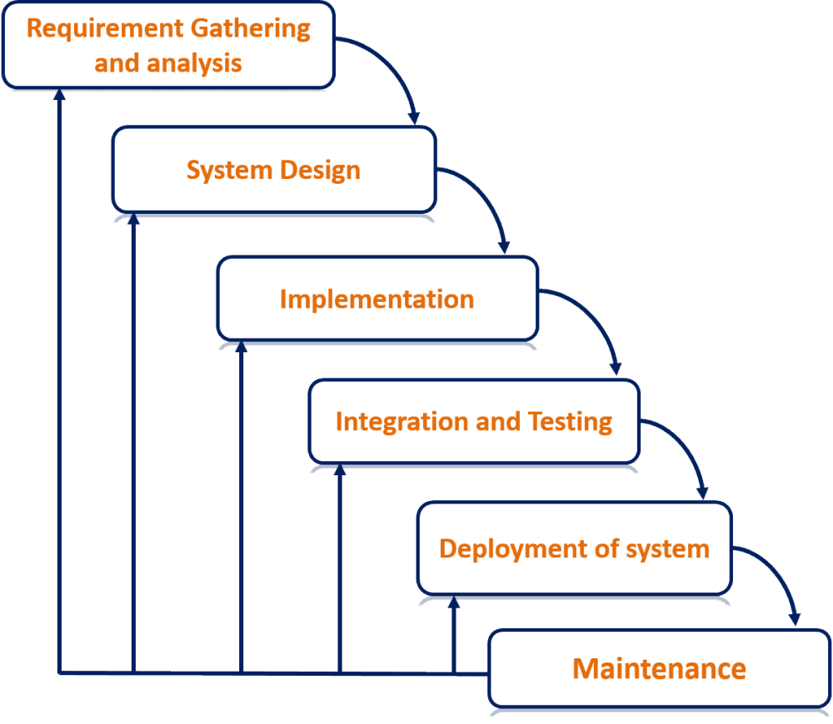

Fig:- Modified Waterfall Model

Here's how the Modified Waterfall Model typically works :-

1. **Requirements Gathering** :- Just like in the Waterfall Model, the project requirements are gathered and documented at the beginning of the process. This phase involves thorough discussions with stakeholders to ensure a clear understanding of what needs to be built.
2. **System Design** :- Following the requirements phase, the system architecture and design are developed. This includes creating high-level and detailed design documents that outline how the system will be structured and how its various components will interact.
3. **Implementation** :- In this phase, the actual coding or development of the software takes place based on the design specifications. Developers write the code according to the design documents created in the previous phase.
4. **Testing** : -Once the implementation is complete, testing is carried out to ensure that the software meets the specified requirements and functions correctly. This includes various types of testing such as unit testing, integration testing, system testing, and user acceptance testing.
5. **Deployment** :- After successful testing, the software is deployed to the production environment or released to end-users.
6. **Maintenance** :- This phase involves ongoing maintenance and support of the software after it has been deployed. This may include bug fixes, updates, and enhancements based on user feedback and changing requirements.

In a modified waterfall model for an e-auction project, thorough planning is followed by sequential execution. The process begins with detailed requirement analysis and design, focusing on user interface, database structure, and system architecture. Implementation includes core functionality development and integration of third-party services. Rigorous testing ensures requirements validation and security. Deployment and ongoing maintenance involve setting up the production environment, deploying to servers, and providing support while incorporating iterative improvements based on user feedback and market trends.

**Database Design**

Database design is the process of creating a detailed data model for a database. It involves defining the structure of the database, including tables, fields, relationships, and constraints, to efficiently store, manage, and retrieve data. The goal of database design is to organize data in a way that supports the requirements of the application while ensuring data integrity, accuracy, and security.

Overall, effective database design is crucial for building robust, scalable, and maintainable databases that support the data management needs of applications and systems. It requires careful planning, analysis, and attention to detail to ensure that the database meets the current and future needs of the organization.

**In our E-Auction project we use MONGO DB as a Database in which Product schema is defined as following :-**

**Product Schema :-**

  title: {

        type : String,

        required : true,

    },

    description : String,

    image : String,

    bidAmount : Number,

    currentBid : Number,

    highestBider : String,

    expirationTime : Date,

* In this schema we have first value **Title** which is the title or name of the product entered,in which required value is **True.** Therefore it is always have to be defined when a new product is entered or old one edited.
* The second one is the product **Description,** which is of string type.
* The third value is the url of the **Image** which is also string type.
* The 4th is the **BidAmount** which is a starting bid amount of a product.
* The 5th is **CurrentBid**  which is used for finding out current bid amount of a product.
* The **HighestBider**  is used to find out the Highest Bidder and the Winner of the Auction held of a specific product.
* The last one **ExpirationTime** is a Date type value which is used to close the Auction on the basis of time and declare a winner.

**Process Design**

* + Process design basically focuses on designing workflows, procedures, and activities within the system.
  + It involves defining how tasks are executed, the sequence of steps involved, and the allocation of resources to accomplish specific objectives.
  + Examples of activities in process design include creating flowcharts, defining standard operating procedures (SOPs), and implementing workflow automation.
  + The primary goal of process design is to streamline operations, improve productivity, and ensure consistency in how tasks are performed within the system.

In summary process design focuses on designing the workflows and procedures within the system to achieve operational efficiency and effectiveness.

**Data Flow Diagram**

A data flow diagram (DFD) maps out the flow of information for any process or system. It uses defined symbols like rectangles, circles and arrows, plus short text labels, to show data inputs, outputs, storage points and the routes between each destination. Data flowcharts can range from simple, even hand-drawn process overviews, to in-depth, multi-level DFDs that dig progressively deeper into how the data is handled. Like all the best diagrams and charts, a DFD can often visually “say” things that would be hard to explain in words, and they work for both technical and nontechnical audiences, from developer to CEO.

**Data Flow Diagram (DFDS) notations :-**

**a.) External Entity :-** External entity is an outside system that sends or receives data, communicating with the system being diagrammed. They are the sources and destinations of information entering or leaving the system. They might be an outside organization or person, a computer system or a business system.

**SYMBOL :-**

**b.)** **Process :-** Any process that changes the data, producing an output. It might perform computations, or sort data based on logic, or direct the data flow based on business rules. Since they transform incoming data to outgoing data,all process must have inputs and outputs on DFDS. A short label is used to describe the process, such as “Submit payment.”

**SYMBOL :-**

**c.) Data Store :-** A data store doesno generate any operations but simply holds data for later access.Data stores could be consists of files held long term or a batch of documents stored briefly while they wait to be processed.

**SYMBOL :-**

**d.) Data Flow :-** The route that data takes between the external entities, processes and data stores. It portrays the interface between the other components and is shown with arrows, typically labeled with a short data name, like “Billing details.”

**SYMBOL :-**

**Zero level DFD**

DFD Level 0 is also called a Context Diagram. It’s a basic overview of the whole system or process being analyzed or modeled. It’s designed to be an at-a-glance view, showing the system as a single high-level process, with its relationship to external entities. It should be easily understood by a wide audience, including stakeholders, business analysts, data analysts and developers.

**User**

**Database**

**1st Level DFD**

The Level 0 DFD is broken down into more specific, Level 1 DFD. Level 1 DFD depicts basic modules in the system and flow of data among various modules. Level 1 DFD also mentions basic processes and sources of information.

**•** It provides a more detailed view of the Context Level Diagram.

**•** Here, the main functions carried out by the system are highlighted as we break into its sub-processes.

**Login**

**Dashboard**

**Select Category**

**Select Product**

**Start Bid**

**Database**

**User**

**Register**

**Is Registered**

**?**

**No**

**Yes**

**ER Diagram**

An Entity Relationship (ER) Diagram is a type of flowchart that illustrates how “entities” such as people, objects or concepts relate to each other within a system. ER Diagrams are most often used to design or debug relational databases in the fields of software engineering, business information systems, education and research.

HighBider Schema

Product Schema

Product Schema

HighBider Schema

Product Schema

Product Schema

HighBider Schema

Product Schema

**CODING**

Coding also known as programming, is the process of creating instructions for computers to execute. It involves writing sequences of commands using a programming language to perform specific tasks or solve problems. Coding is the backbone of software development.

**Here is the complete coding of our E-Auction Website entitled BidZone.**

**SNAP SHOTS :-**

Navigation Bar

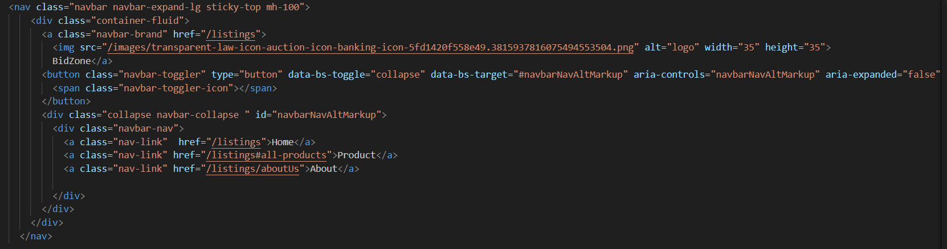

Output



Home Page



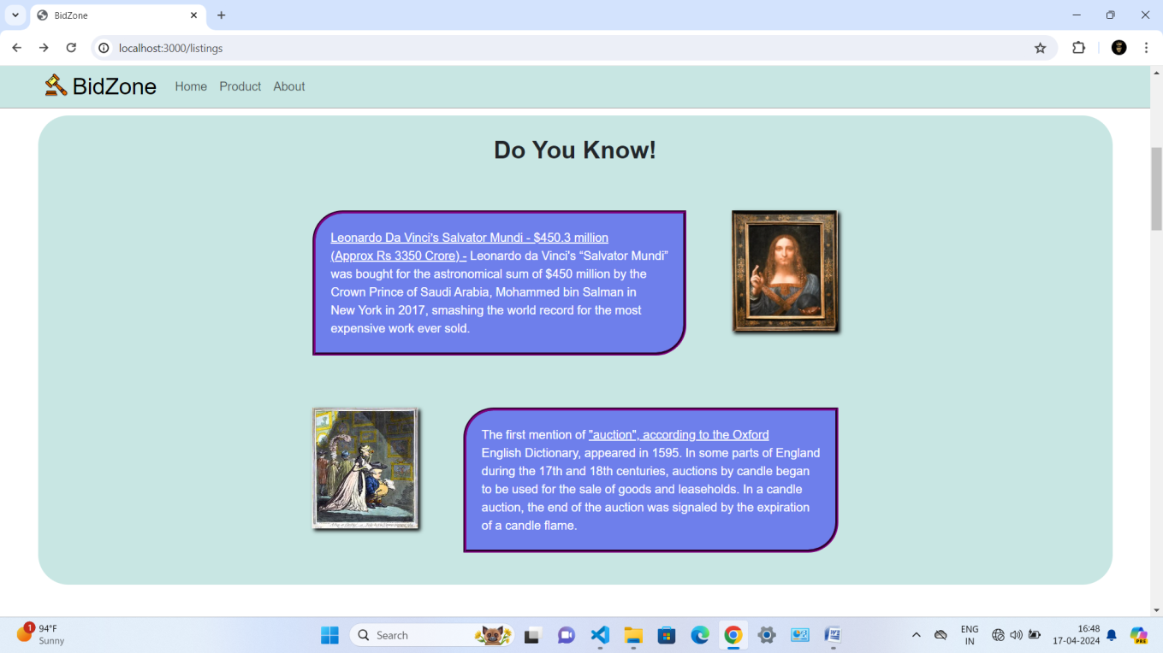

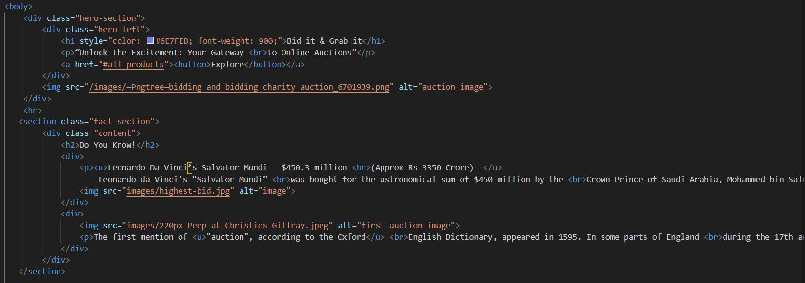

Product Section

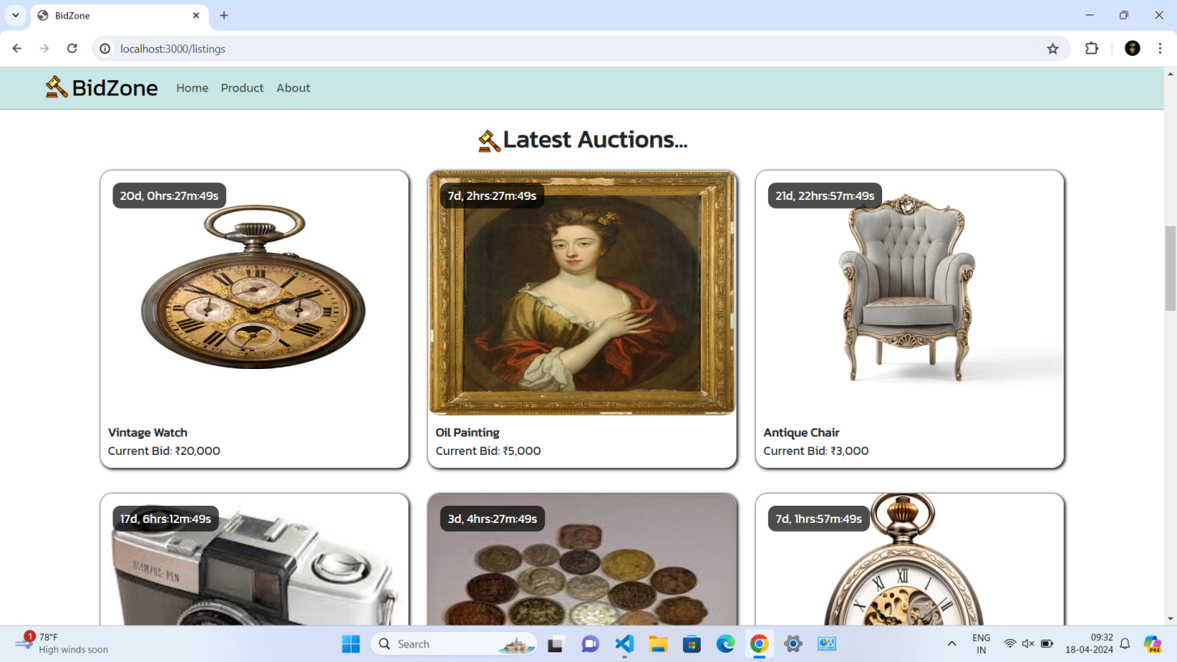

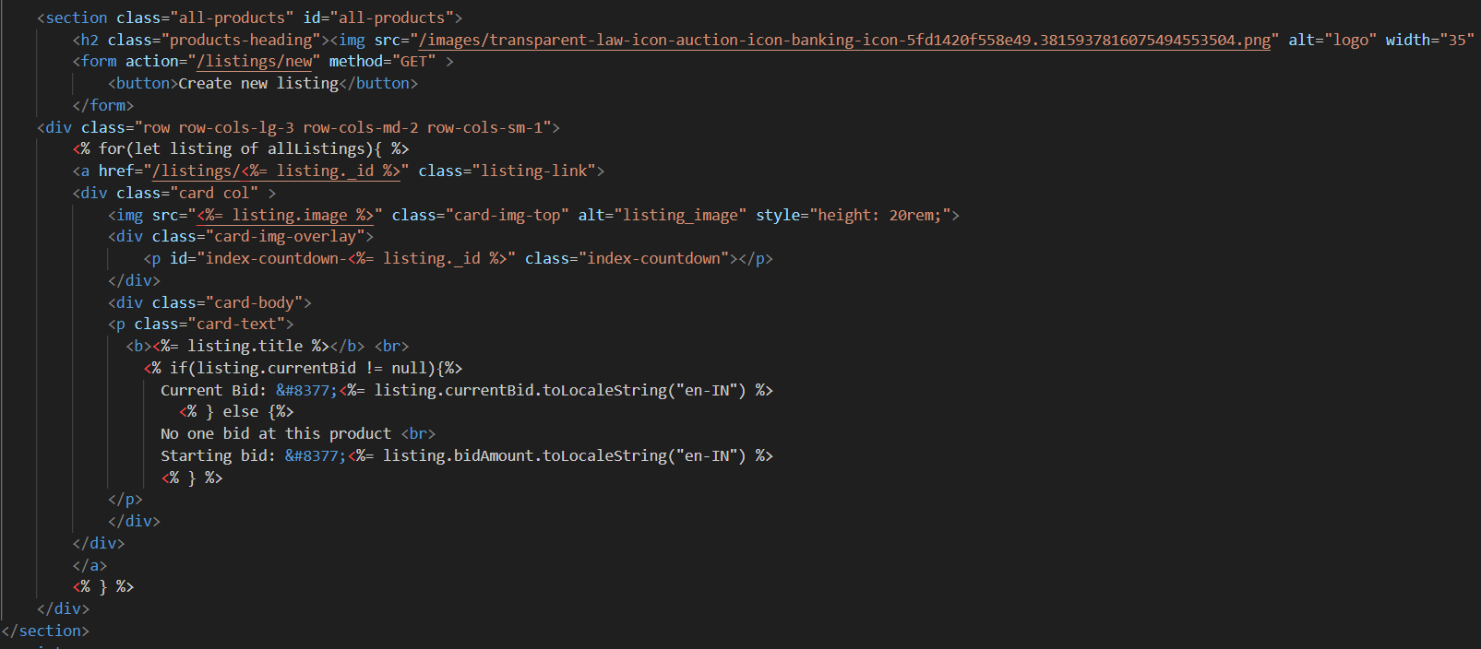

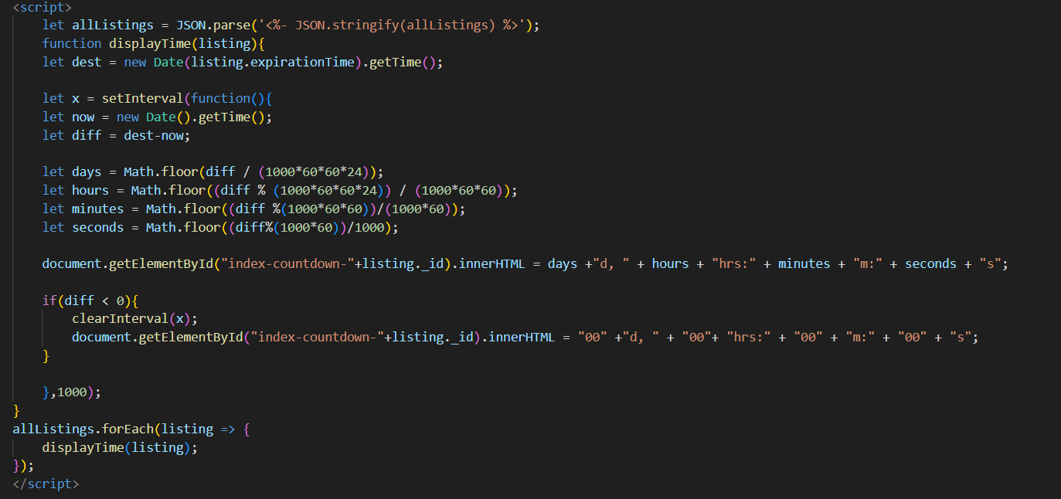

Footer Section



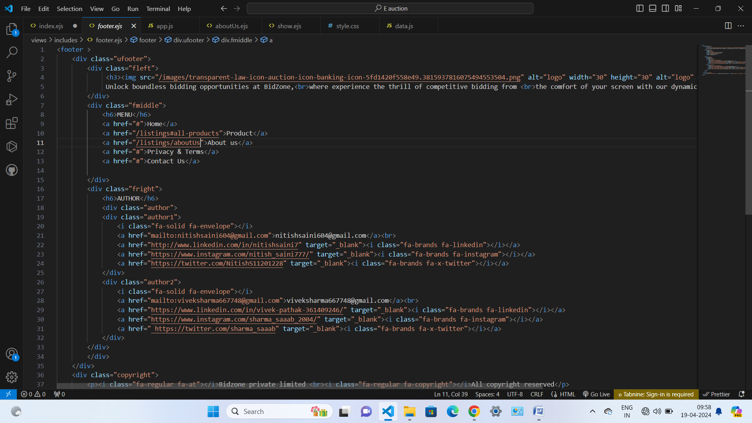

AboutUs Page

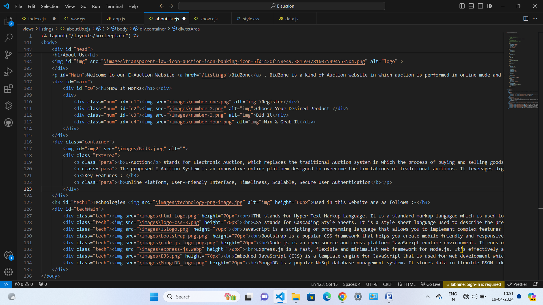

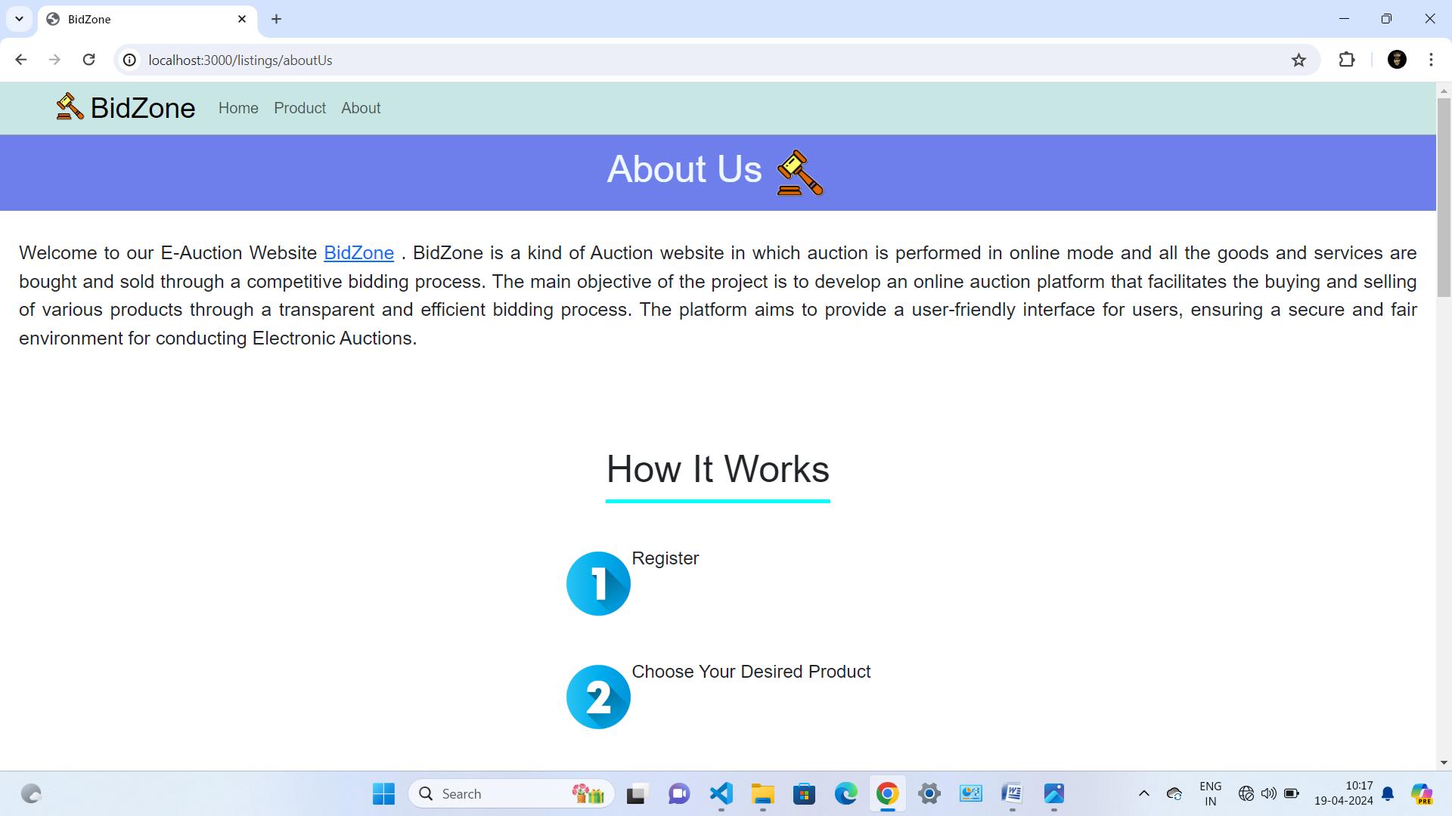

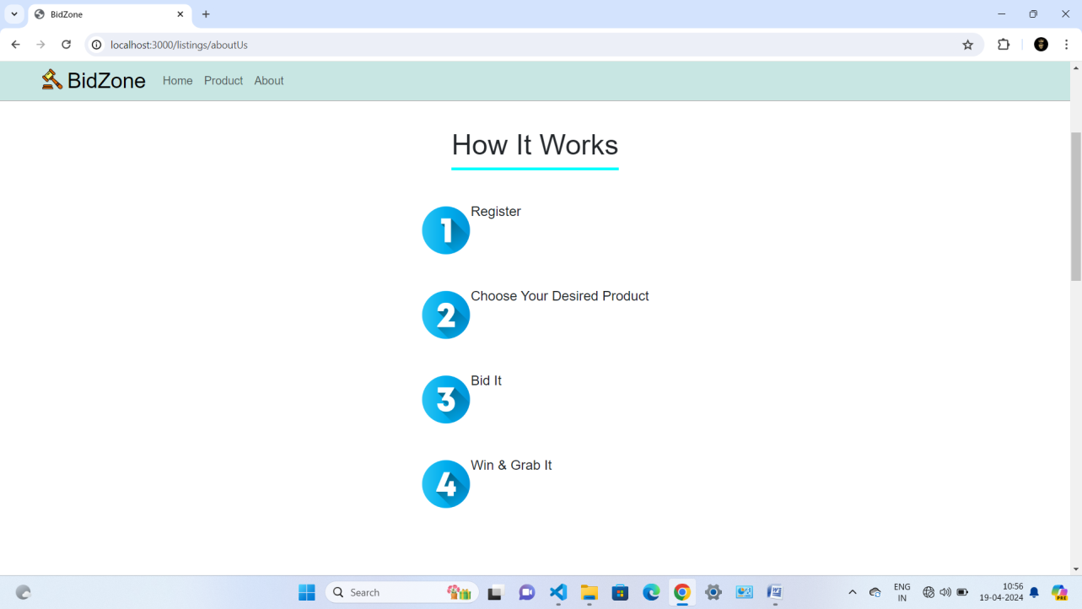

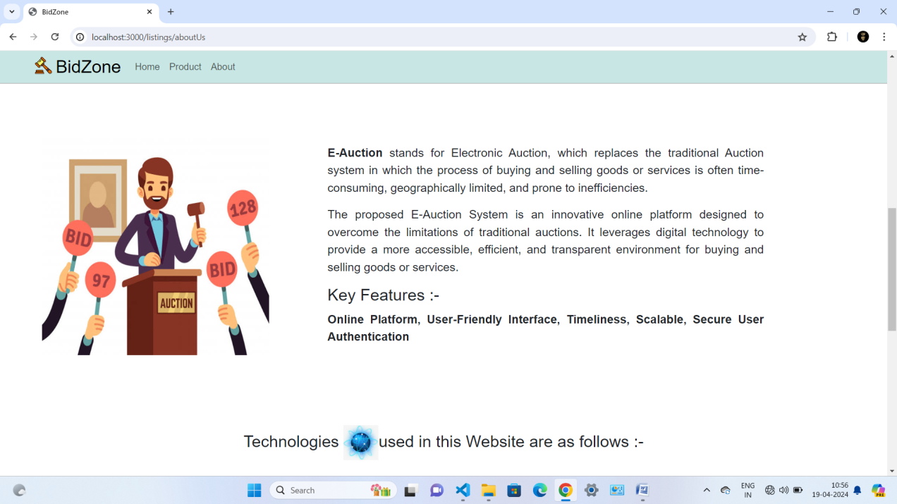

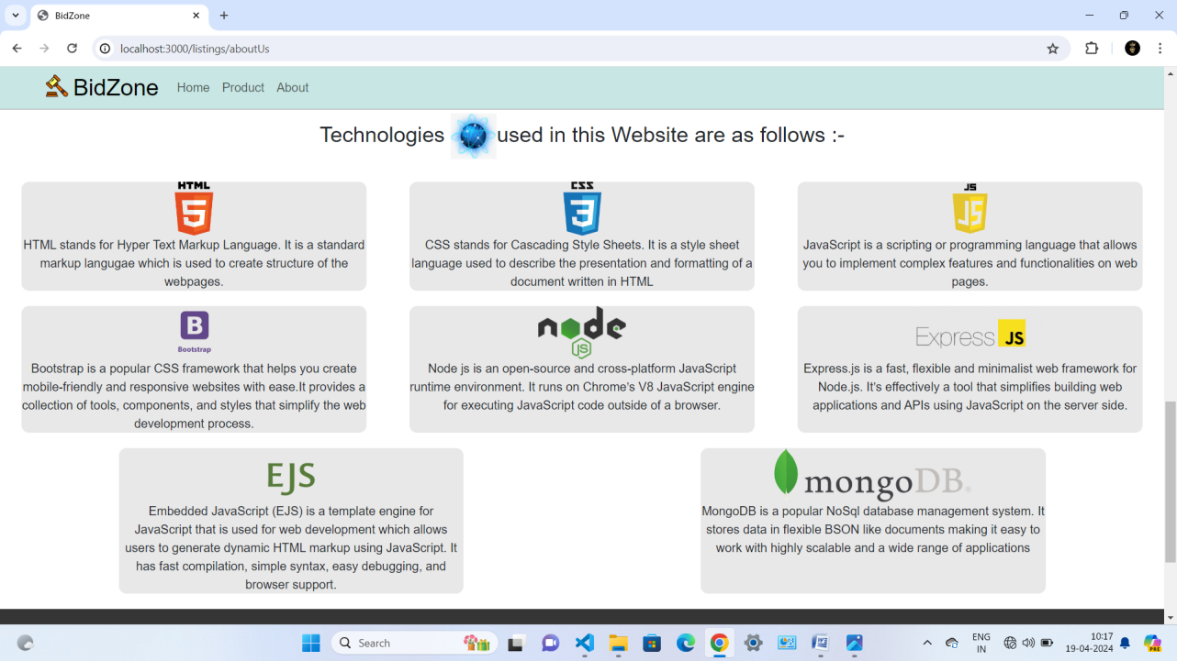

Create Listing Form

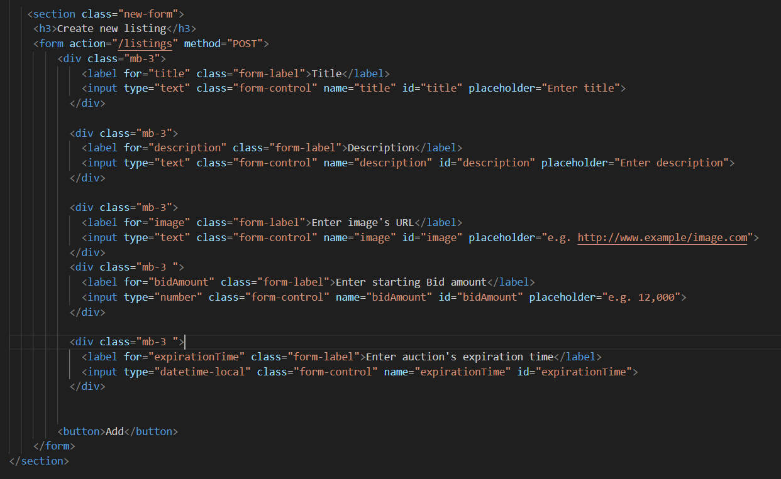

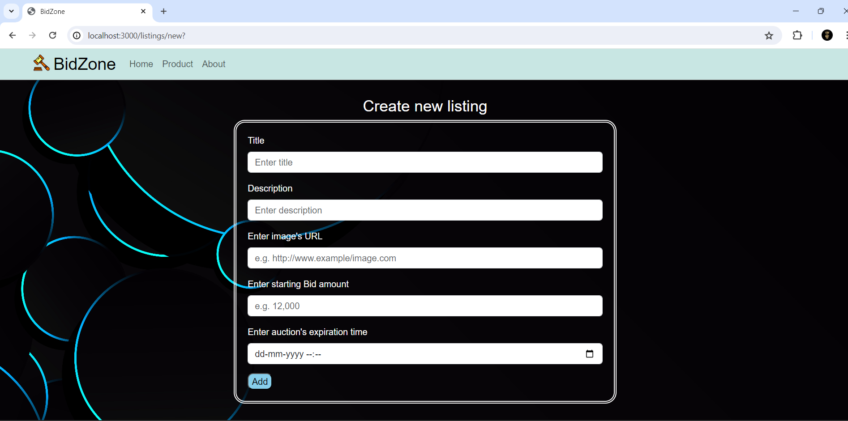

Edit Listing Form

